**3)Configuration Management:**

Tool: Puppet

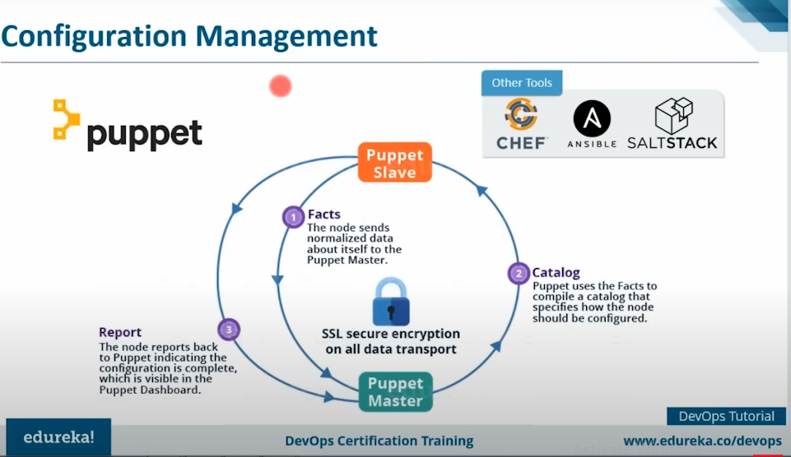

### How Puppet Works:

1. **Resource Abstraction:** In Puppet, system resources (like files, users, services, packages, etc.) are abstracted into **resource types**. These resources define the state you want (e.g., a file should exist, or a service should be running).
2. **Puppet Code Definition:**
   * Puppet code is written in **manifests** and defines the desired state of each resource.
   * Example of a simple manifest to ensure the Apache service is installed and running:

Puppet code

package { 'httpd':

ensure => installed,

}

service { 'httpd':

ensure => running,

enable => true,

}

1. **Agent-Master Communication:**
   * The **Puppet Agent** (installed on managed nodes) periodically checks in with the **Puppet Master** server (central control node) to retrieve configuration information.
   * The Puppet Master compiles this information into **catalogs**, which are descriptions of the desired system state for each node.
   * The agent applies the catalog to its system and ensures that the system matches the desired state.
   * If the system deviates from the desired state, Puppet corrects it to match the defined configuration.
2. **Reporting and Enforcement:**
   * After applying the configuration, the agent sends a report back to the master indicating success or any issues.
   * Puppet continuously monitors and applies the configuration, ensuring systems remain consistent with the defined state (drift management).
3. **Idempotency:** Puppet is designed to be **idempotent**, meaning that applying the same manifest multiple times will not change the system if it is already in the desired state.

**Use Cases:**

* **Server Configuration:** Installing and configuring software packages, ensuring services are running, and managing files.
* **Scaling Infrastructure:** Puppet simplifies managing configurations across thousands of servers by applying consistent configurations automatically.
* **Compliance:** Ensuring all systems are compliant with security or organizational policies.
* **Continuous Delivery/DevOps:** Puppet can be integrated into CI/CD pipelines to automate deployments and manage environments.

**Puppet Workflow:**

1. **Write Puppet Code:** Define the desired configuration in manifests.
2. **Apply Configuration:** Agents periodically communicate with the master, pull the manifests, and apply the configurations.
3. **Monitor & Enforce:** Puppet continuously monitors the systems and ensures they stay in compliance with the defined configuration.

Puppet is a great fit for teams looking to manage infrastructure as code, particularly for large, complex environments that require consistent configuration enforcement across multiple systems.

**Containerization**

**Tool: Docker**

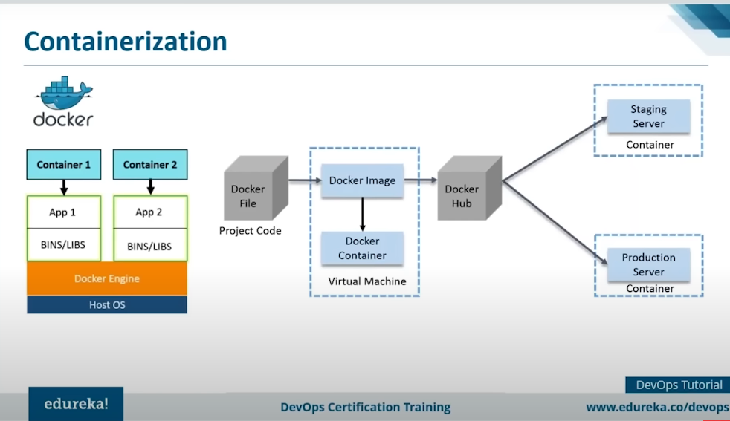

**Docker Containerization**

**Docker containerization** is a lightweight and portable method for deploying, running, and managing applications. It enables developers to package an application along with all its dependencies (libraries, configuration files, and environment) into a container, which can be run on any system that supports Docker.

**How Docker Containerization Works**

1. **Docker Engine**:
   * At the core of Docker is the **Docker Engine**, which creates and manages containers. It uses Linux's native functionality, specifically cgroups and namespaces, to isolate and manage resources (CPU, memory, disk I/O) for containers.
2. **Images**:
   * Docker containers are created from Docker **images**, which are immutable files that contain everything needed to run a piece of software. Docker images are made up of multiple layers (base image + custom layers) and are stored in registries like Docker Hub.
3. **Containers**:
   * A **container** is a runtime instance of a Docker image. It is an isolated, self-sufficient environment that includes everything required to run the application (e.g., code, system libraries). Multiple containers can run on the same system without interfering with each other, because they are isolated.
4. **Dockerfile**:
   * To create a Docker image, developers use a **Dockerfile**, which is a text file containing instructions on how to build the image. It defines the base image (e.g., Ubuntu), dependencies, environment variables, application code, and any commands that should be run when the container starts.
5. **Layered File System**:
   * Docker uses a **layered file system**, where each instruction in the Dockerfile creates a new layer. Docker caches these layers, allowing for faster builds and smaller image sizes. This layering makes Docker images efficient, as unchanged layers don’t need to be rebuilt or re-downloaded.
6. **Isolation**:
   * Docker containers provide process and filesystem isolation using namespaces. Each container runs in its own namespace, ensuring that it cannot access the processes or files of other containers or the host machine directly.
7. **Portability**:
   * Since containers encapsulate the entire environment, they can be run on any system with Docker installed. This makes Docker containers highly portable and ideal for CI/CD pipelines, cloud deployments, and microservices architectures.

**Key Components of Docker:**

* **Docker CLI (Command-Line Interface)**: Allows developers to interact with Docker, such as pulling images, starting containers, and managing volumes.
* **Docker Daemon**: The background service responsible for building, running, and managing containers.
* **Docker Hub**: A cloud-based repository where Docker images can be stored, shared, and downloaded.

**Benefits of Docker Containerization**

1. **Consistency Across Environments**:
   * Containers ensure that an application runs the same way in development, testing, and production environments.
2. **Lightweight**:
   * Unlike virtual machines (VMs), Docker containers share the host system's kernel and do not require a full guest OS, which makes them lightweight and fast.
3. **Resource Efficiency**:
   * Containers are more efficient than traditional VMs because they use fewer resources. Several containers can run on the same machine, using less CPU, memory, and storage than equivalent VMs.
4. **Scalability**:
   * Containers can be easily scaled up or down in a microservices architecture, allowing applications to handle increased loads.
5. **Rapid Deployment**:
   * Docker's fast startup times make it possible to quickly spin up or destroy containers, enhancing the speed of development and testing cycles.

**Typical Workflow:**

1. **Build the Docker Image**: Use a Dockerfile to define the environment and app dependencies.
2. **Run a Container**: Launch the application inside a container using the docker run command.
3. **Push to Docker Hub (Optional)**: Share the image with other developers or deploy it to different environments using Docker Hub.
4. **Orchestration (Optional)**: Tools like **Kubernetes** can be used to manage large-scale container deployments.

Docker makes development, testing, and deployment faster, more consistent, and portable across different computing environments.

**Continuous Monitoring**

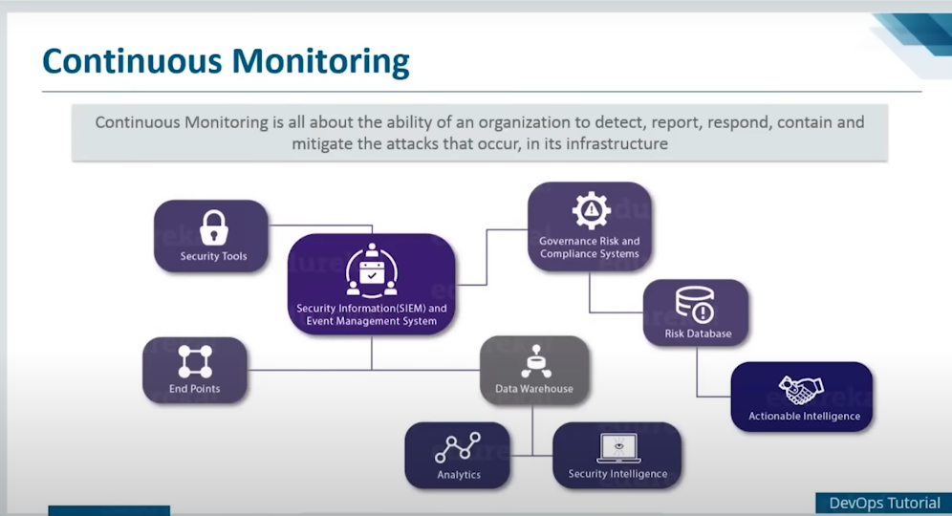

Tool: Nagios

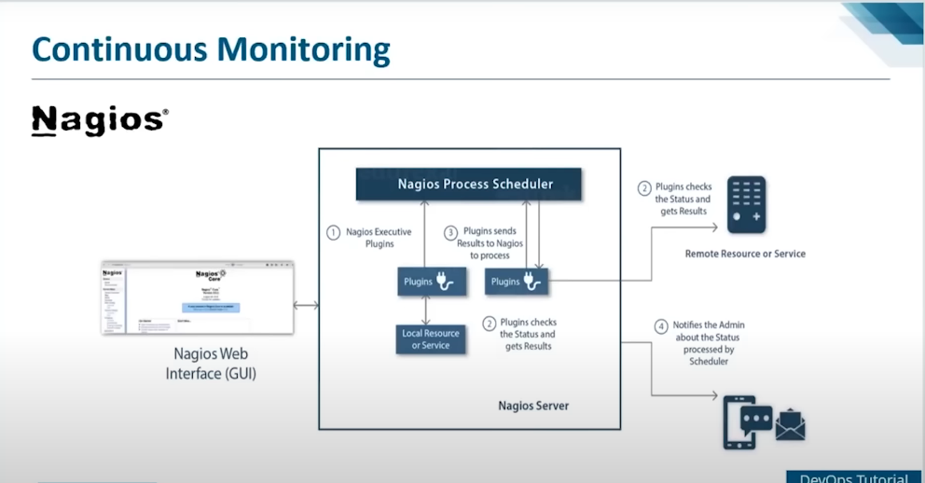

**Nagios** is a popular open-source monitoring tool used for continuous monitoring of IT infrastructure, applications, and services. It helps ensure that systems, networks, and applications remain operational by continuously monitoring their status and alerting administrators when issues are detected. Here's an overview of how Nagios works and its features:

**Key Features of Nagios:**

1. **Network Monitoring**: Nagios monitors network services like HTTP, SMTP, FTP, SNMP, SSH, and more.
2. **Host and System Monitoring**: It checks the status of physical or virtual machines, such as CPU usage, disk space, memory usage, and server uptime.
3. **Alerting**: When problems arise, Nagios sends notifications through various channels like email, SMS, or push notifications, enabling quick response.
4. **Event Handlers**: Automatically restart services or run custom scripts to fix problems when certain events occur.
5. **Web Interface**: Provides a web-based GUI for users to monitor system status in real-time and view logs.
6. **Extensibility**: Supports plugins, making it highly customizable for various monitoring tasks.

**How Nagios Continuous Monitoring Works:**

1. **Monitoring Configuration**:
   * Administrators define the monitoring configuration using a set of config files, which include details of hosts, services, and commands.
   * Hosts are systems (e.g., servers, devices), while services are functionalities running on those systems (e.g., web servers, databases).
   * **Plugins** are used to perform specific checks, and administrators define what needs to be monitored using these plugins.
2. **Plugins**:
   * Nagios relies on external plugins to gather information about the system's status.
   * These plugins execute checks (e.g., is the web server responding? Is the disk space usage normal?) and return the result (OK, WARNING, CRITICAL, etc.).
   * Administrators can either use built-in plugins or develop custom plugins based on their requirements.
3. **Polling**:
   * Nagios operates on a **polling** mechanism, where it regularly checks the status of defined hosts and services based on the schedule set in its configuration.
   * It polls devices, systems, or services at regular intervals to ensure they're operational.
   * This approach helps in continuous monitoring as it gives a snapshot of the system at predefined intervals.
4. **Alerting Mechanism**:
   * If a problem is detected during polling (e.g., a service is down or a resource is over-utilized), Nagios generates an alert.
   * Alerts are sent to administrators or teams based on predefined escalation policies. For example, a critical service downtime might trigger an immediate SMS alert, while a minor issue could trigger an email.
   * Alerting thresholds can be customized so that alerts are sent only when certain thresholds are breached (e.g., CPU usage > 90%).
5. **Event Handlers**:
   * Event handlers can be triggered automatically when an alert is generated, allowing Nagios to try to resolve the issue autonomously.
   * For example, Nagios can be configured to restart a service if it detects that it’s down.
6. **Web Interface**:
   * Nagios offers a web-based dashboard that provides a clear, real-time view of the monitored systems' health.
   * Users can view logs, reports, and performance graphs through this interface, aiding in issue diagnosis and proactive monitoring.
7. **Notifications and Reporting**:
   * Notifications can be customized, and various plugins support different forms of notifications like Slack, SMS, or email.
   * Nagios generates reports that show trends over time, helping to identify recurring issues or to understand system behavior under load.
8. **Extensibility**:
   * Nagios supports numerous plugins, making it flexible for monitoring a wide range of devices, services, and applications.
   * With the help of **NRPE (Nagios Remote Plugin Executor)**, it can even monitor remote systems.
   * The **Nagios Exchange** community offers thousands of ready-to-use plugins and add-ons.

**Typical Workflow:**

1. **Define Hosts and Services**: Specify what you want to monitor.
2. **Schedule Polling**: Configure how often Nagios should check the status.
3. **Use Plugins for Checks**: Nagios uses plugins to gather information.
4. **Issue Alerts**: When thresholds are breached, Nagios sends alerts.
5. **Auto-Remediation (Event Handlers)**: Fix certain issues automatically.
6. **Web Dashboard**: Monitor systems and receive real-time feedback through a web interface.

**Use Cases:**

* **IT Infrastructure Monitoring**: Keep track of hardware, servers, switches, and routers.
* **Application Monitoring**: Ensure applications like databases, web servers, and messaging services are running smoothly.
* **Service-Level Agreement (SLA) Monitoring**: Measure and report on SLAs by tracking uptime and performance metrics.

In summary, Nagios is a robust tool for continuous monitoring that helps administrators stay on top of their IT environment, identifying issues before they impact users or business operations. It integrates well with other tools and can be extended to meet specific monitoring needs.

**DevOps Use-Case**

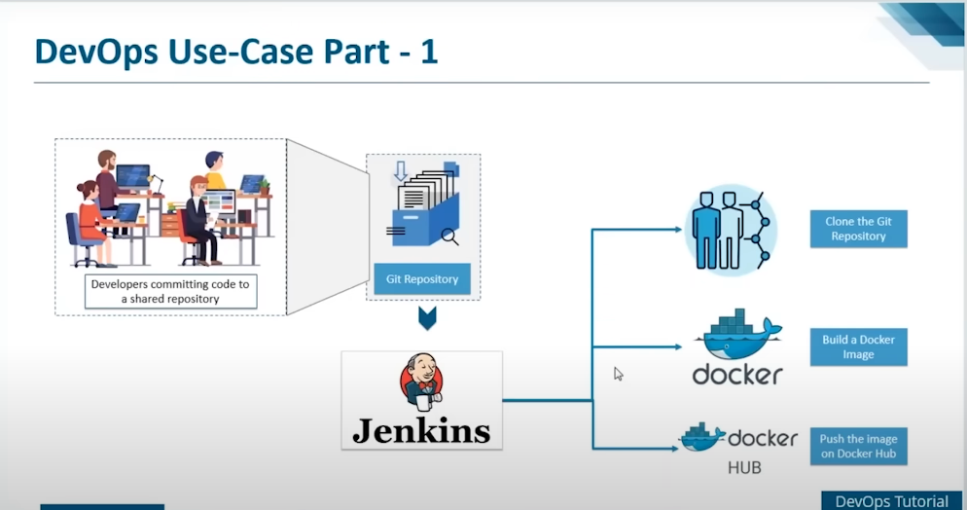

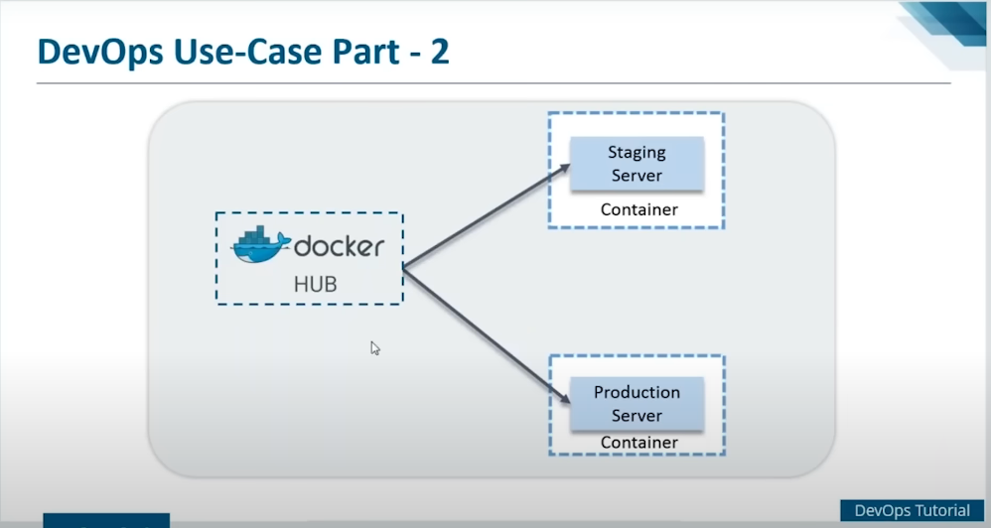

**Version Control System**

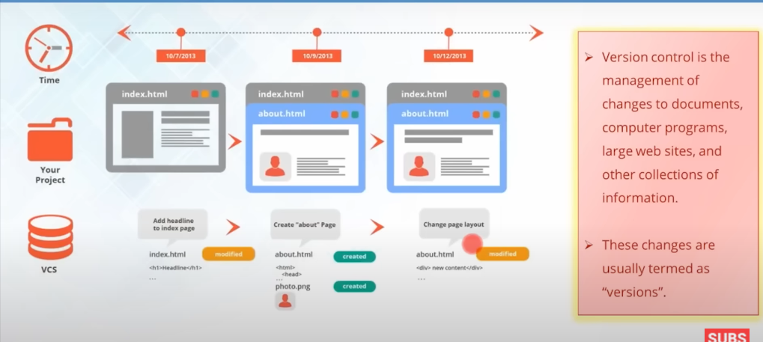

Tool: Git and GitHub

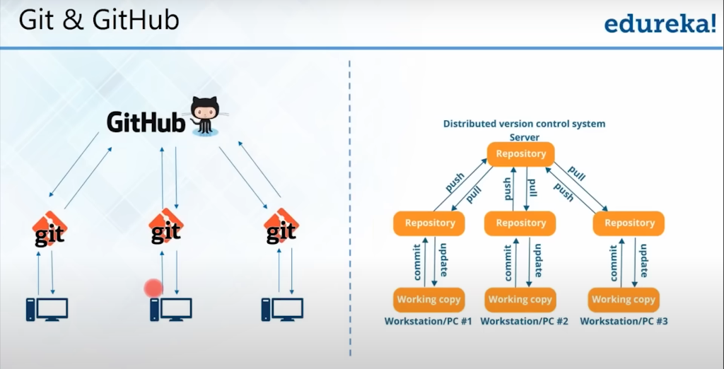

**Git Commands**

1. **git init** ★  
   Initializes a new Git repository in your project directory.
2. **git clone [repository-url]** ★  
   Copies a repository from GitHub (or any other remote repository) to your local machine.
3. **git status** ★  
   Displays the state of the working directory and staging area, showing which files are modified, staged, or untracked.
4. **git add [file]** ★  
   Adds specific files to the staging area for the next commit.
5. **git add .** ★  
   Adds all changes in the working directory to the staging area.
6. **git commit -m "[message]"** ★  
   Records changes to the repository with a message describing the updates.
7. **git commit --amend**  
   Modifies the most recent commit, allowing you to edit the commit message or add new changes.
8. **git push origin [branch]** ★  
   Sends your committed changes to a remote repository (like GitHub).
9. **git push -u origin [branch name]**  
   Pushes the branch to the remote and sets it as the default for future pushes.
10. **git pull origin [branch name]** ★  
    Fetches the latest changes from the remote repository and merges them into your current branch.
11. **git fetch**  
    Downloads objects and refs from another repository without merging.
12. **git merge [branch]**  
    Merges a specific branch into the current branch.
13. **git branch** ★  
    Lists all local branches in the repository.
14. **git branch [branch-name]**  
    Creates a new branch.
15. **git checkout [branch]** ★  
    Switches to the specified branch.
16. **git checkout -b [branch-name]**  
    Creates and switches to a new branch in one step.
17. **git rebase [branch]**  
    Moves or combines a sequence of commits to a new base commit, useful for keeping commits linear.
18. **git log** ★  
    Displays the commit history for the repository.
19. **git diff**  
    Shows the differences between the working directory and the staging area.
20. **git reset [file]**  
    Unstages a file without deleting the changes.
21. **git reset --hard [commit]**  
    Resets the index and working directory to the state of the specified commit.
22. **git stash**  
    Temporarily saves changes that are not yet ready to be committed.
23. **git stash pop**  
    Applies stashed changes back to the working directory.
24. **git rm [file]**  
    Removes a file from the working directory and stages the removal.
25. **git tag [tag-name]**  
    Tags a specific commit to mark important points in your history.

**GitHub-Specific Commands**

1. **git remote add origin [url]** ★  
   Links your local repository to a remote one, typically on GitHub.
2. **git remote -v**  
   Shows the URLs of remote repositories.
3. **git fork**  
   Creates a copy of someone else's repository on GitHub (done via GitHub UI).
4. **git pull request**  
   Opens a pull request to merge your changes into another repository (done via GitHub UI).
5. **git issue**  
   Used for managing issues and tracking tasks (done via GitHub UI).
6. **git clone --depth 1 [repo-url]**  
   Clones a repository but only retrieves the most recent history, making it faster.
7. **git rebase --onto [branch]**  
   Re-applies commits from your current branch onto another base branch, maintaining a clean history.
8. **git cherry-pick [commit-hash]**  
   Applies the changes from a specific commit onto the current branch.

**Most Important Commands Summary**

* **git init**
* **git clone**
* **git status**
* **git add**
* **git commit**
* **git push**
* **git pull**
* **git branch**
* **git checkout­**
* **git log**
* **git remote add origin**

**Continuous Integration Using Jenkins**

